Question 1
- 1 – phenylalanine, 2 – arginine, 3 – isoleucine, 4 – glutamic acid, 5 – asparagine, 6 – aspartic acid
- N-terminus: blue, C-terminus: red
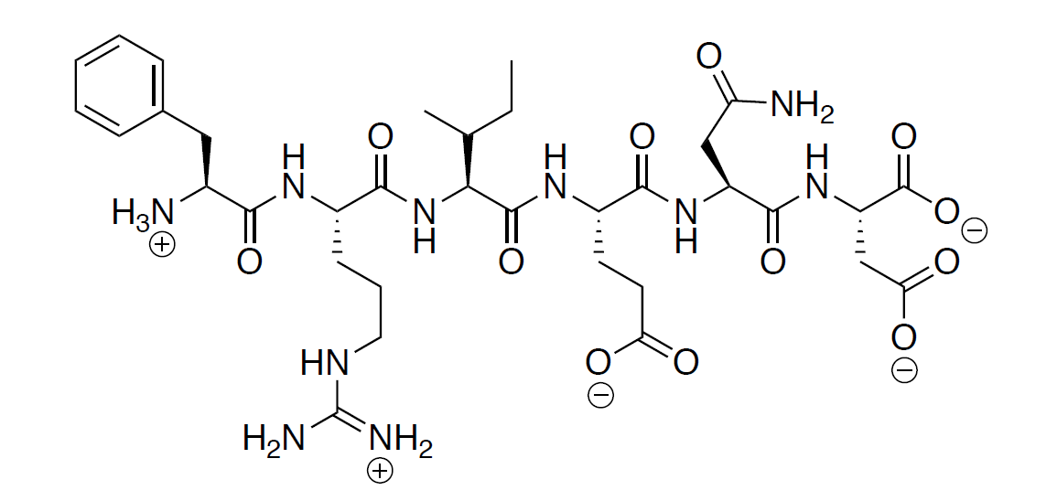

- Primary:
Secondary:
Tertiary:
Quaternary:

Question 2
- C, A, G

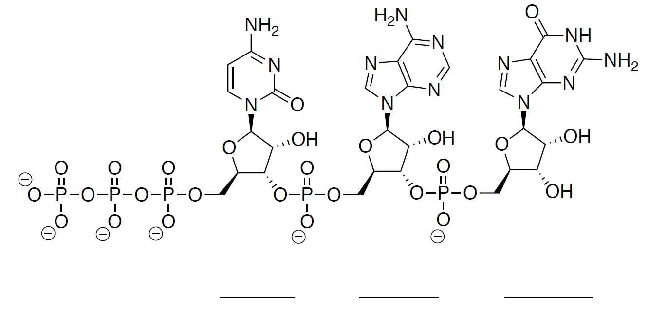
3’
5’
G
A
C
- RNA, as the sugar in the molecule is a ribose instead of deoxyribose. It has a hydroxyl group at carbon number 2 of the sugar.
- 5’ C T G 3’
- Hydrogen-bonding of the nucleobases

Question 3
- It’s in alpha-form as the acetal oxygen is pointing backward (hashed bonds). If it is drawn in chair conformation or Haworth’s projection, it would point down.
- C₁₁H₂₂O₁₁
- Disaccharide as it is formed from two simplest sugar (monosaccharide), joined by a glycoside bond.
- 9 Stereocenters.
- 2⁹ = 512 stereoisomers possible.

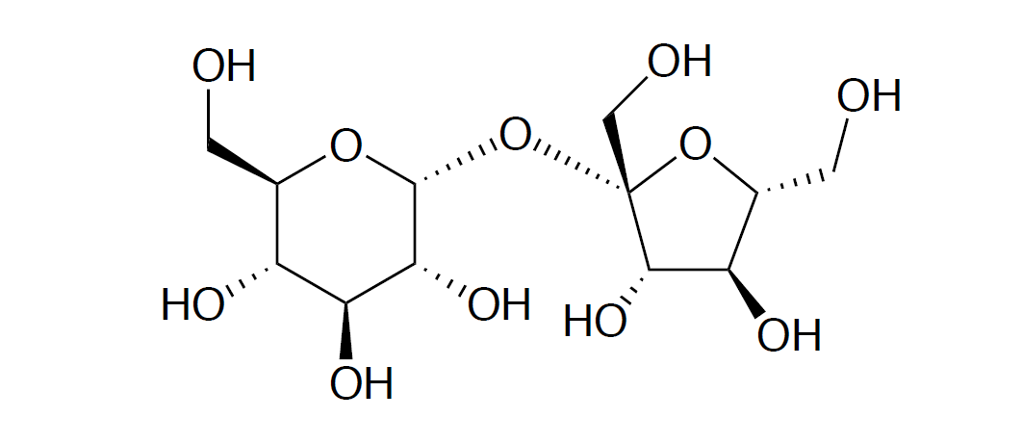

R
*
- The hydroxyl groups, as they are able to form hydrogen-bonds with water.

